**For Loops:**

- A *for* keyword indicates the start of a for loop  
- A *temporary variable* that will store the contents of the items being iterated on  
 - Name is arbitrary and can be anything, does not need to be pre-defined  
 - Best practice is to make it as descriptive as possible  
- A *in* keyword separates the temporary variable from the permanent variable  
- A *collection­* of items to loop over  
- An *action* to perform on each iteration of the loop   
 - Needs to be indented within body of *for* loop  
 - Everything at this level or lower will run in every iteration of loop  
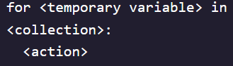 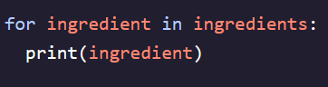

**Using Range:**

- To create arbitrary collections of any length, use built-in function *range()*- Use a variable name ***different*** than the one for the variable being printed - Loop iteration number can be tracked by printing out the *temporary variable* +1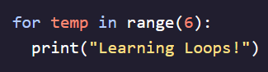 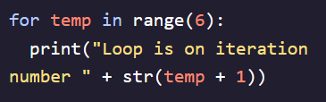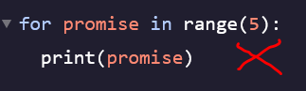 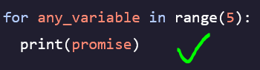

**While Loops:**

- Performs a set of instructions as long as a given condition is true  
- Count remains indented under print because it will execute directly afterwards  
- By using *len()* function as condition of loop start/stop we can iterate through any list   
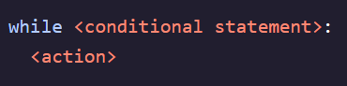 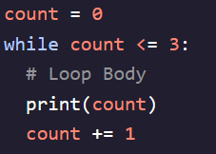

**Loop Control – Break:**

* Loops will continue to iterate all the way through to the end unless stopped with code
* Can use a ***break*** statement to immediately stop a loop  
  A computer screen shot of text

  Description automatically generated

**Loop Control – Continue:**

* Used when we want the loop to continue while only skipping the current iteration
* When code encounters a condition that breaks the action rule, it immediately skips the current iteration and loops through to the next one  
  **A black background with white text

  Description automatically generated** A computer screen with text

  Description automatically generated with medium confidence 

**Nested Loops:**

* Can nest *for* loops together when we need to iterate through nested lists  
  A black background with yellow and orange text

  Description automatically generated A screenshot of a computer code

  Description automatically generated